**Guidance Class Lesson for the week of May 11-15**

**Let’s learn about handling anger: Lesson 5**



Hello 2nd grade students! I miss you all so much!

This week we are learning about how to handle a very important emotion called, anger. Everyone has anger sometimes, and it really is okay to feel angry. The thing to learn is how to handle the feeling of anger. How we ACT when we feel angry is MOST IMPORTANT so that no one gets hurt! Even though it is hard, we can learn to handle our anger!

1.Watch the video: “When Miles Got Mad.”

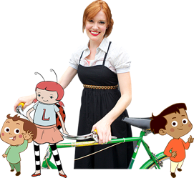

<https://www.youtube.com/watch?v=lP0R9SYt4KU>

2.Read the book, “Cool down and work through Anger,” By Cheri J. Meiners.

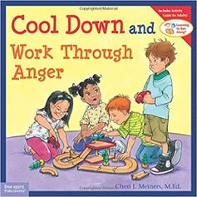

<https://www.youtube.com/watch?v=fTT9EgtaXbA>

3. Listen to these songs when you are feeling mad or frustrated.



<https://www.youtube.com/watch?v=ca8SUuG8vdA>

<https://www.youtube.com/watch?v=F2XVfTzel8E>

4. Here is an activity to print about handling anger. Handling Anger